
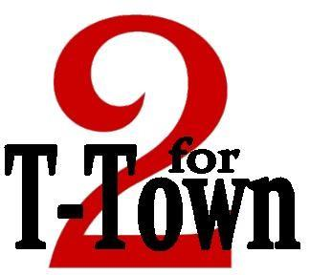
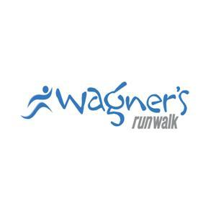
Wednesday, July 4, 2014 7:30am – NorthRidge Fitness

Name (full):
(first) (last) (middle)

Male Female Tshirt Size: S M L XL

Address:

(street)

(city) (state) (zip)

Phone: Work: ( ) - Cell: ( ) -

Itinerary: Course: Divisions:

6:30a.m. – Registration | 2-Mile | 15 & under
7:30a.m. – Race Start |  | 16-25
 |  | 26-35
Cost: |  | 36-45
Pre-registration (before JULY 1st) - $12 |  | 46-55
Late Registration: (After July 1st) - $16 |  | 55 & up

Location:

NorthRidge Fitness

300 McFarland Blvd N Tuscaloosa, AL 35476
Guest Waiver – Read Carefully
I agree that all exercises, treatment and use of 2 for Tuscaloosa should be undertaken at
my own risk. I am in good physical condition and physically able to participate in exercise and treatments provided by NORTHRIDGE FITNESS, Wagner's RunWalk all sponsors, volunteers and their respective agents and employees. NORTHRIDGE FITNESS, Wagner's RunWalk, all sponsors, volunteers and their respective agents and employees shall not be liable for any claims, demands, or injuries, whatsoever, to me or my property. I do hereby expressively forever release and discharge NORTHRIDGE FITNESS, Wagner's RunWalk, all sponsors, volunteers and its respective agents and employees from any and all claims

Participant Name (PRINT)

Participant Signature or Guardian Signature if participant in under 18 years old

